Call (231) 234-3424 F T Y

Ford Historic Homes District

|  |  |  |  |  |  |
| --- | --- | --- | --- | --- | --- |
| home | about | events | resources | merchandise | contacts |

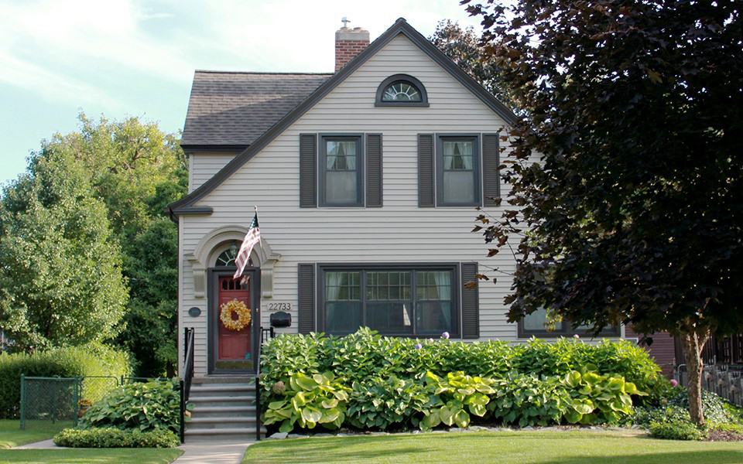WOWSlider.com

|  |  |  |
| --- | --- | --- |
| Image result for ford historic district | about FHHD  ____________  Ford Homes Historic District History  by Joseph Oldenburg  In late 1918 the Henry Ford & Son tractor plant, located south of the present Conrail tracks and east of present  Oakwood, employed some 400 men… | Image result for ford historic district |

Events

_____________

|  |  |
| --- | --- |
| Saturday March 24, 2018 | Saturday, April 12, 2018 |
| Easter Egg Hunt | Town hall Meeting |
| http://fordhomes.org/wordpress/wp-content/uploads/2016/03/Easter_eggs.jpg | District Meeting |
| Duvall Park | Duvall Elementary |

resources

____________

|  |  |
| --- | --- |
| Ford homes historic district preservation guidelines  Lorem ipsum dolor sit amet, consectetur adipiscing elit, sed do eiusmod tempor incididunt ut labore et dolore magna aliqua. Ut enim ad minim veniam, quis nostrud exercitation ullamco laboris nisi ut aliquip ex ea commodo consequat. Duis aute irure dolor in reprehenderit in voluptate velit esse cillum dolore eu fugiat nulla pariatur. Excepteur sint occaecat cupidatat non proident, sunt in culpa qui officia deserunt mollit anim id est laborum… | Bylaws for the ford historic home district  Lorem ipsum dolor sit amet, consectetur adipiscing elit, sed do eiusmod tempor incididunt ut labore et dolore magna aliqua. Ut enim ad minim veniam, quis nostrud exercitation ullamco laboris nisi ut aliquip ex ea commodo consequat. Duis aute irure dolor in reprehenderit in voluptate velit esse cillum dolore eu fugiat nulla pariatur. Excepteur sint occaecat cupidatat non proident, sunt in culpa qui officia deserunt mollit anim id est laborum… |

merchandise

____________

To purchase or for more information call Pat Johnson (791-0071)

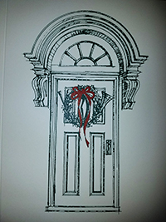 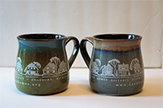 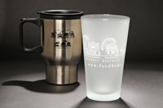 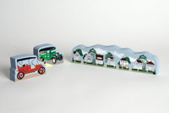 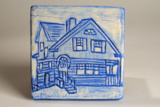 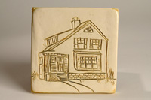

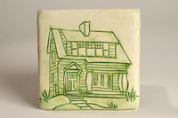 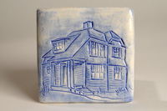 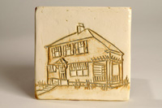 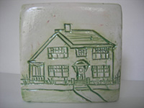 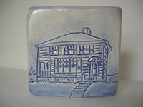 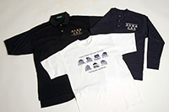 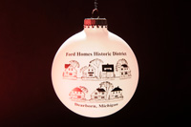

contacts

____________

|  |  |  |
| --- | --- | --- |
| Related image | Image result for committee icon | Related image |
| District Officers | Building Committee | Canopy Rental |
| Image result for merchandise icon | Related image | Image result for packet icon |
| Merchandise | Sign Rental | Welcome Packets |

All rights reserved… F T Y

